Project Management Plan

For

**Location Tracking Shoe for Kids**

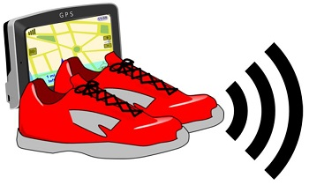

Client

Dr. Aziz Fellah

**Prepared by**

* Jeevan Bodigam – Project Manager
* Nagarushyanth Tummala – Team Lead
* Ajay Kumar Reddy Arram – Test Engineer/Jr. Developer
* Amulya Mallepalli – Software Developer
* MadhuBabu Konda – UI/UX Developer

Table of Contents

1. Integration Management 3

1.1. Project Statement 3

1.2. Overview 3

1.3. Success Criteria 3

2. Scope Management 3

2.1. Project Justification 3

2.2. Product Characteristics 4

2.3. Product Requirements 4

2.4. Product User Acceptance Criteria 4

2.5. Product-related deliverables: 4

3. Stakeholder Management 5

3.1. Stakeholder Register 5

4. Schedule Management 5

4.1. Work Breakdown Structure (WBS) 6

5. Cost Management 7

5.1. Cost Estimate 8

6. Quality Management 8

6.1 Quality Standards 9

6.2 Problem Reporting and Corrective Action Process 10

6.3 Supplier Quality and Control 11

7 Resource Management 11

7.1 Organization Structure 11

7.2 Staffing Requirements 11

8 Communication Management 12

8.1 RACI Matrix 13

9 Risk Management 14

9.1 Risk Mitigation Strategies 15

10 Procurement Management 16

11 Constraints 18

12 Issues 18

# Integration Management

## Project Statement

The project “Location tracking shoe for kids” is a shoe with a GPS tracker installed in the sole. The shoe would be wirelessly connected to the parent’s mobile application developed by our team through which they would be knowing the child’s live location.

## Overview

The Reason for giving this title is as it is meant for tracking real time location for children who are vulnerable of missing, kidnapping or being a victim of child trafficking. This project would intend to act like a voice to these children, helping their parents to track their location, preventing them to be a part of any danger or harm. The statistics say that every year at least 300,000 children go missing around the world from their family. They are either trafficked, abducted or abused, or the children get lost due to their vulnerability. Thus, this project would be addressing the social issue of child related crime and hopefully, it will reduce the huge numbers of such cases.

The location would be tracked through an application in the parent’s phone, connected with the shoe’s GPS sensor. The parent can access the child’s location at any part of the world.

Initially, this project would be launching approximately 100,000 shoes and observing the response over two years., the production capacity would increase for 100000 every year for the next 5 years.

## Success Criteria

The success criteria of the project lie when there would be a reduction of child related crime like human trafficking, kidnapping, missing etc. to at least 20% in the first 2 years of the project launch. It also depends how the parents of up to 7 years old children feel the shoe proves to be convenient for them as the project addresses the concern for their children’s safety, especially when they are away from them. Thus, over a period of 5 years, the above-mentioned crime could lead to a further decrease up to 60 % in such crime if the projects get assistance from the government initiatives. These 5 years could lead to the evolution of this project in other kids’ wearable business-like cap, school bag, etc.

# Scope Management

## Project Justification

The proposed project provides customers a hassle-free location tracking services which could track real time location for children who are vulnerable of missing, kidnapping or being a victim of child trafficking. The project must comprise of balances reasonable cost, effort, timely delivery, quality, and functionality. Scope planning is the first key step of a project before its implementation or execution. It is the blueprint of any project which includes each and every minute to major components of the project. It basically gives the information of what should be included and what should not be included in the project.

## Product Characteristics

* The primary use of technology here would be for tracing the location of the children, i.e., through GPS tracker installed in the shoe’s sole and a software application to view the location in a smartphone.
* In order to make the tracker more durable and long lasting, stronger and high-quality soles would be outsourced to protect the battery cells and the tracker.
* The software application could be installed in both high end as well as low end devices for accessibility to the people of different.

## Product Requirements

* **Hardware requirements:**

Shoes, GPS tracking device, Mobile device, employee’s infrastructure

* **Software Requirements:**

Java, HTML, CSS, Bootstrap, JavaScript, Visual Studio, Agile, Gantt charts.



## Product User Acceptance Criteria

* The application should be accessible on both android and iOS mobile devices.
* User data must be very confidential.
* GPS tracker must be hackproof.
* Shoes should be waterproof.
* All features are easily accessible in the application.

## Product-related deliverables:

Research reports, design documents, software code, hardware, etc.

* Bug’s log
* Application performance report
* Documentation
* Incremental application updates
* Database schema
* UML Diagrams
* GPS firmware update list

# Stakeholder Management

This analysis shows the position, power, interest and benefits of our team associated with the project and people who are within our organization. This shows us everybody's importance and their behavior towards the project.

## Stakeholder Register

|  |  |  |  |  |
| --- | --- | --- | --- | --- |
| **Name** | **Position** | **Internal/External** | **Project Role** | **Contact Information** |
| Jeevan Bodigam | Project Manager | Internal | Project Manager | S542039@nwmissouri.edu |
| Nagarushyanth Tummala | Team Lead | Internal | Project Lead | S543652@nwmissouri.edu |
| Amulya Mallepalli | Team Member | Internal | Software Developer | S542411@nwmissouri.edu |
| Ajay kumar reddy Arram | Team Member | Internal | Test Engineer/ Jr. Developer | S541989@nwmissouri.edu |
| Madhu babu konda | Team Member | Internal | UI/UX Developer | S542311@nwmissouri.edu |
| Aziz Fellah | Client | External | End User | afellah@nwmissouri.edu |
| Ben | Customer support | Internal | System user | Ben123@gmail.com |
| Alberto | Material | External | Supplier | albert@gmail.com |
| Joe | Trainer | External | Technical and soft skills trainer | Joe989@gmail.com |
| John | COO | External | Sponsor | John345@gmail.com |
| Kids | Customers | External | End Users | N/A |
| Parents/Teachers | Customers | External | End Users | N/A |

# Schedule Management

Scheduling in project management is a list of activities, deliverables, and milestones within the project. Typically, the schedule also includes planned start and end dates, duration, and resources assigned to each activity. Effective project scheduling is a key component to successful time management.

## Work Breakdown Structure (WBS)

# Cost Management

A proper and calculative cost planning ensures that the project would be completed and operational as per its approved budget. This can be successfully done by proper planning, managing and controlling the overall cost of the project in all the concerned departments. This project has already designed in such a way that it would reduce operational and manufacturing cost up to 30% as most of the components are being outsourced and the primary function includes assembling those components in the unit. Since the project is completely novel and has never been attempted, we do not have a rough draft or sketch to get reference from. Therefore, it is important to be extra cautious wild budgeting this project.

|  |  |  |  |  |
| --- | --- | --- | --- | --- |
|  | Direct Cost | Indirect Cost | Recurring Cost | Non- recurring cost |
| Project Manager cost | ╳ |  | ╳ |  |
| GPS cost | ╳ |  |  | ╳ |
| Shoe Material cost | ╳ |  |  | ╳ |
| Machinery and Equipment cost | ╳ |  |  | ╳ |
| Application Development cost | ╳ |  | ╳ |  |
| Programming cost | ╳ |  |  |  |
| Administration cost | ╳ |  | ╳ |  |
| Overhead Expenses |  | ╳ | ╳ |  |
| Survey cost |  | ╳ |  | ╳ |
| Quality Assurance cost | ╳ |  |  | ╳ |
| Labour cost | ╳ |  | ╳ |  |
| Operating Cost | ╳ |  |  | ╳ |
| Logistics cost | ╳ |  |  | ╳ |

## Cost Estimate

Project management cost estimation is the process of predicting the financial and other resources needed to complete a project within a defined range. The cost is calculated as the total amount that determines the budget of the project, taking into account each factor required for the project, down to the labor of materials.

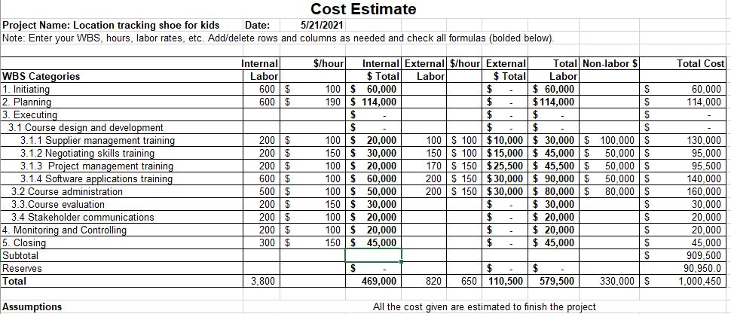The project we estimated was around 1 million USD but the sponsor/client has assigned 3.5 million USD for the manufacturing the shoe installed with GPS Tracker and development of application.

# Quality Management

Quality and standard planning is the vital element of this project as the developed product through this would be novel in the market. Hence, the quality of the output as well as input has to be such that the cost should not be escalated in the future, the goals of the project should be met uncompromised. The resources used, features of the shoes, materials used should not be compromised, especially when it is meant to be used by vulnerable kids. The desired quality can only be achieved when the stages of development of this project, its process, its production also meets the standard.

|  |  |  |
| --- | --- | --- |
| Categories | Cost of  Conformance | Cost of Non-Conformance |
| Training the worker to assemble the the different parts | X |  |
| Quality of the material used to make the shoe vamp | X |  |
| Testing the accuracy of the GPS chip | X |  |
| Overall design & comfort |  | X |
| Testing the shoe’s response to water, dirt, etc | X |  |
| App and trackers synchronization | X |  |
| Checking the smooth user interface of the application | X |  |
| Searching for bugs, virus, bloatwares. | X |  |
| Sufficient power and quality cells for the GPS chip |  | X |
| Automation and functioning of machineries | X |  |

## Quality Standards

The principles and methodologies applied should be maintained in the following items:

All principles referenced in risk management should be maintained. There is a set of coding gauges that developers need to maintain as they complete their work.

One must maintain standards identified by privacy, secure code push, etc.

**Metrics**

|  |  |  |  |
| --- | --- | --- | --- |
| **S No** | **Defect Level** | **Defect Name** | **Measurements** |
| 1 | High-Level Defects | Wrong Estimation,  Not allocating work to an ideal individual,  Planning errors | Project estimation is more appropriately possible and should not be given enough time to evaluate the project. Project managers need to have better information than general information about their partners and their abilities, and they need to work the same way. Attention should be paid in the preparatory stage with the goal of avoiding fainting later. |
| 2 | Mid-level Defects | Bugs,  Integration issues | Bugs are standard in all projects, ensuring good testing and quality claims. The test collection should be well-learned about a wide range of modules, as the modules are grouped together and can cause overall effort and exactly some issues. |
| 3 | Low-level Defects | Screen Resolution,  Hard-disk specifications | PC screen resolution may not be a big deal, but if it's based on points of interest, you need to be able to do a better job. |

## Problem Reporting and Corrective Action Process

* If there are problems, such as all missions / errands that do not fulfill the quality standards, they must be counted at this time. The movement required should be connected to the problem.
* Should determine quality-related tools to support the quality.
* We should characterize and plan quality control and plan to report quality assurance issues.
* Each improved edition must be solved by the high-end officials when time permits, and a critique should be done at team members and stakeholders.

## Supplier Quality and Control

* All information is calculated according to the corresponding time.
* Should have no problems to be able to transfer data and applications that are not collapsed when an increasing number of users who use it simultaneously use.
* User interface is pleasant and friendly. Users should use it.
* All looking for a look and the feeling should be fulfilled.

# Resource Management

We define the roles and positions which will define everybody's work. This is basically our project team who will carry out the whole project and the below chart shows who is in charge of who.

## Organization Structure

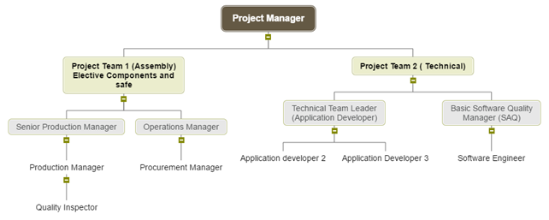

## Staffing Requirements

To determine human resource needs, we need to pay attention to the following points.

• Commercial objectives and project deliverables of the division

• Candidate's technical skills

• Candidate's general skills

• Type of worker (direct hire, contract)

This project will require the following internal staff:

**Project Manager:**

Responsible for driving the entire project throughout the system development cycle.

**Project Lead:**

Responsible for leading people and making sure the project moves forward. He joins the group, motivates them and cares about their needs. It maintains a productive work environment.

**Project Developers:**

Responsible for the planning as well as the supervision of various projects within the company.

**Staff Assignments**

**Project Manager:**

Interact with the entire team to identify customer requirements and update work status.

**Project Lead:**

Track daily tasks and get work assigned to them. Then they recorded their work. Team members collaborate with their team leader. Job status update for the project manager and responsible for daily scrum meetings.

**Team members:**

Track daily tasks and get work assigned to them. Then they recorded their work. Team members collaborate with their team leader.

**Client:** Interact regularly with the project manager and attend meetings. Any clarification on doubts and comments will be given to them.

# Communication Management

An effective communication is the key to success of any organization or business. It is very important that the team members, stake holders should function smoothly, keeping the goals of that project in mind. It also plays an important role in sharing ideas and knowledge in the organization. A proper medium of communication is very necessary for the flow of decision, direction and suggestions related to the project.

A daily meeting will be conducted to check the daily growth of the Project; all senior managers need to attend the meeting. Meeting will be headed by Project Manager (Venue: Colden Hall 3500, Time: 9:00AM).

## RACI Matrix

|  |  |  |  |  |  |  |  |
| --- | --- | --- | --- | --- | --- | --- | --- |
|  | **Project**  **Manager** | **Production Manager** | **Production Team** | **Technology Manager** | **Technical Team** | **Testing Team** | **Operation Team** |
| **Project**  **Management**  **Plan** | R, A | R | C | R | C | - | C |
| **Product**  **Development**  **Plan** | C | R, A | I | I | I | - | I |
| **Software**  **Development**  **Plan** | C | I | I | R, A | I | C | I |
| **Testing Plan** | C | C | I | C | I | R, A | I |
| **Launching Plan** | C | I | I | I | I | I | R, A |

|  |  |  |  |  |
| --- | --- | --- | --- | --- |
|  | **Meeting** | **Responsible** | **Attendees** | **Location** |
| **1** | Project start | Project  Manager | All teams | Colden Hall 3500 |
| **2** | App  Development Status | Senior  Technology Manager | Technical leader  Software Quality  Manager | Colden Hall 3500 |
| **3** | Status of product  Assembling | Senior  Production Manger | Production Manger  Supporting Team | Colden Hall 3500 |
| **4** | Quality  Check  Status | Quality  Manager | Quality Inspector | Colden Hall 3500 |
| **5** | Testing  Check  Status | Testing Manager | Testing Team | Colden Hall 3500 |
| **6** | Operation Status | Senior operation  Manager | Operation  Managers  All  supporting team members | Colden Hall 3500 |
| **7** | Pre Launch  Status of the Project | Project  Manager | All Team leaders and members | Colden Hall 3500 |

# Risk Management

Identifying and realizing the risks associated with project is important to cope up with the threat or any mismanagement in the future or present. The entire team should always be prepared with the resources for any difficulties that might occur so that all the various concerned department should know how to cope with them. All the risks in the project should be classified according to the priority, level of risk, and possible solutions. This could make it easier for the managers to find a feasible and successful solution.

|  |  |  |  |  |  |
| --- | --- | --- | --- | --- | --- |
| S no | Risk | Responsible | Priority | Mitigation | Contingency |
| 1 | The workers in the assembling unit might not be technically skilled | H.R.  Manager | High | Proper training needs to be provided | Experienced workers can be hired through recruitment agencies after screening various candidates |
| 2. | Imported shoe vamp’s quality might be compromised | Quality Manager | Med | Proper observation and testing of samples before placing order | Change to a different supplier |
| 3. | Cost fluctuation due to unstable forex | Financial Advisor | Low | Flexible project cost. | In case of price hike, cost cutting would need to be done from other department. |
| 4 | Inaccuracy of GPS trackers | I.T Engineer | High | A random  test of 100 trackers in every slot | Replacement of shoe. |
| 5. | Incompatibility of tracking app for various phones | Software Engineer | High | Beta testing to make sure it covers up  as maximum phones | Frequent Software updates |
| 6 | Damage due to weather/water/wear and tear | After Sales service/ Quality manager | Low | Quality check before releasing the project. | 1-year warranty. |
| 7. | Replication of project idea | Legal Team | Medium | Filing patent and copyright |  |

## Risk Mitigation Strategies

|  |  |  |  |
| --- | --- | --- | --- |
| **Risk Rank** | **Major Risks** | **Strategies to mitigate risks** | **Responsibility** |
| 1 | Market Risk | * The client should like the product. * Tracking performance/quality of comparative items in the market. | Project manager  Project Lead |
| 2 | Financial Risk | * We need to allocate abundance cash for the project for future financial issues. * At each stage we need to calculate the cash inflow and cash outflow toward the end. | Project Manager  Project Lead |
| 3 | Technical Risk | * We ought to improve the issue taking care of skills. * Emphasize the team support. * Project monitoring recurrence ought to be expanding. | Project manager  Team Member(Sr. Consultant)  Team Member(Jr. Consultant) |
| 4 | People Risk | * Recruiting the individuals/employees from various regions. | Project Manager  Project Lead |
| 5 | Structure/ process risk | * Defining all the goals of the project obviously. * Selecting most experienced people/project manager/workers. * Increasing the recurrence of monitoring. | Project Manager  Project Lead |

# Procurement Management

Procurement planning involves activity regarding products, components, services related to the product which would be brought outside the organization. This basically means that there are certain, or all elements of the product would be outsourced from suppliers for various reasons like cost, time, quality and feasibility and risks.

A lot of discussion, research, finding and brainstorming should be done to finalize any decision regarding procurement. Since the project is involves primary of assembling different components altogether, most of them would be procured from various suppliers, most importantly the GPS tracker and shoe vamp.

# 

|  |  |  |  |
| --- | --- | --- | --- |
| **Quantity** | **Description** | **Reason Cost** | |
| 2 | Hire Human resource manager | Who will seek the 40000 human resource need in the organization | |
| 1 | App Developer | For Developing the Application | 10000 |
| 1 | GPS kit Supplier | For Fulfilling our need of GPS | 10000 |
| 1 | Shoe vamp Supplier | For upper part of the shoe | 20000 |
| 1 | Raw material Supplier of “sole” | For Manufacturing the sole | 30000 |
| 1 | Purchase of Sole  Manufacturing  Machine | For Manufacturing the sole | 35000 |
| 2 | Hire Engineers | For planning the setup of production unit | 3000 |
| 4 | Hire Technicians | For operation of machines | 18000 |
| 3 | Hire installation engineers | For installing and  setting up the machines | 10000 |
| 2 | Hire GPS  Programmers | Programming of GPS | 6000 |
| 20 | Hire Labour | For assembling sole and vamp together to make complete shoe | 13000 |
| 5 | Hire GPS installers | Installation of GPS in shoe | 1500 |
| 1 | Hire software engineer | Integrate the GPS with application | 1200 |
| 2 | Hire testers | For testing the product | 900 |
| 1 | Quality inspector | Checking the quality and comfort | 1300 |
| 1 | Hire survey expert | Performing and evaluating survey | 1500 |

# Constraints

* Mobile application has to be monitored and taken care by external application or software developer.
* As few parts would be outsourced from a different country (Vietnam or Bangladesh), it would take time to reach the inventory due to import, custom duties.
* Dependency on internet for mobile application.
* Since the project has to be child friendly, a lot of strictness from the government guidelines and regulations.
* Varying Government regulations in various countries due to presence of GPS tracking

# Issues

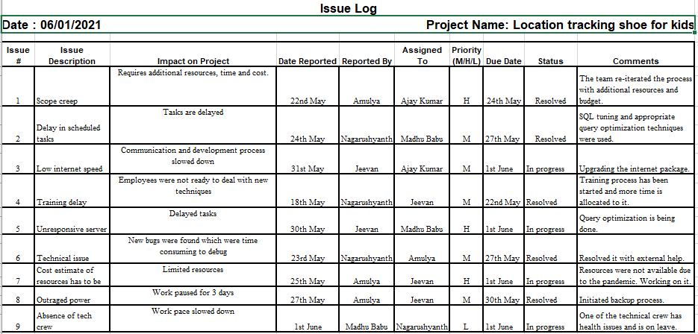Any project, no matter how big or small, how significant or insignificant, if operational, faces issues and challenges. But this issue can be overcome and tackled if the team members are dedicated, experienced and skillful enough. The hinderance does not arise when a project has issues, it arises only when the project fails to come up with solution.